UNIT 1

FLOWCHART

EXERCISES

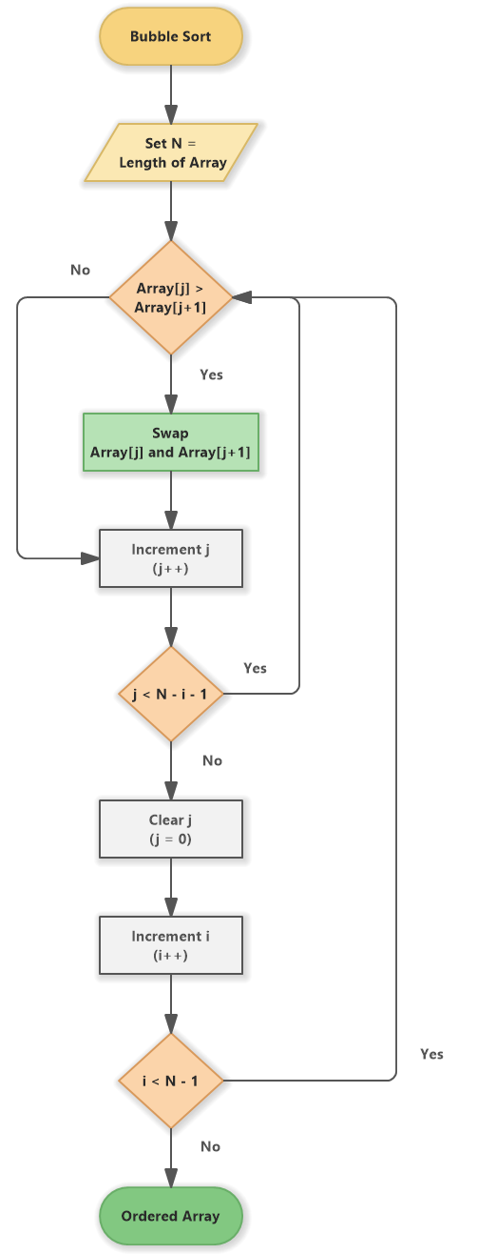

**ANSWER 12: -**

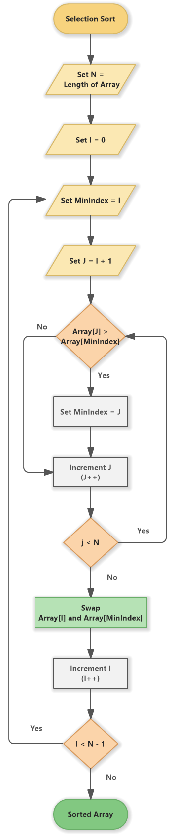

**ANSWER 14:-**

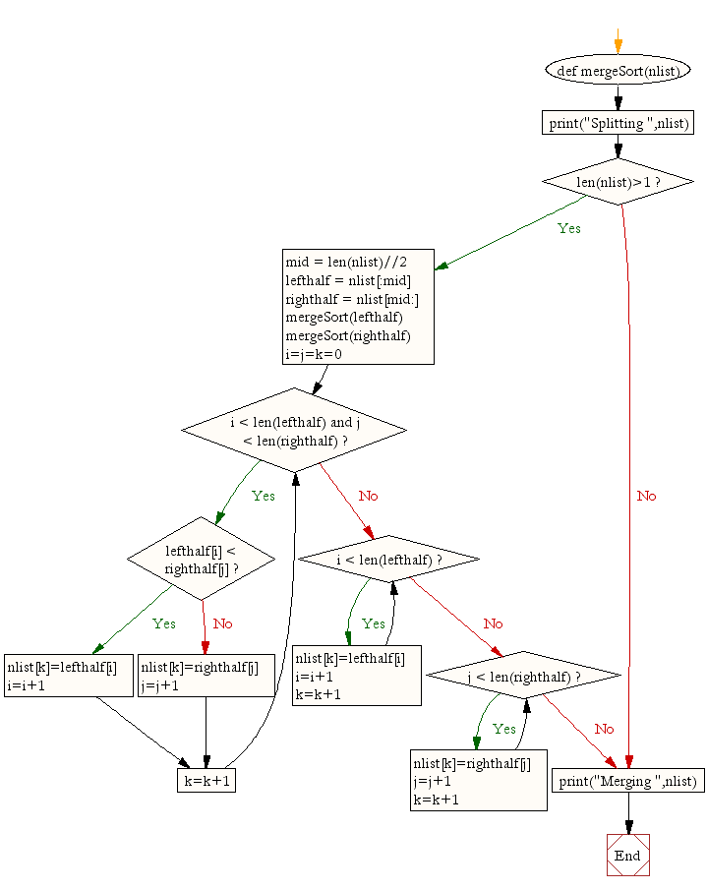

ANSWER 15:-

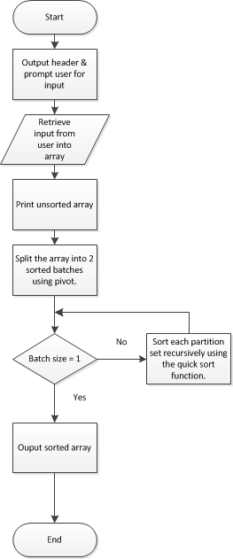

ANSWER 16:-

